Levels of Branding
Branding is a complex concept that goes beyond simple product identification. It represents a journey from fundamental recognition to embodying values and philosophies that resonate emotionally and psychologically with consumers. Experts have studied the evolution of branding through six levels, ranging from functional aspects to deeply representational elements that define global brands.

1. Functional vs. Representational Branding
The branding spectrum shifts from purely functional elements (such as product names and attributes) to representational branding that aligns with human values and corporate philosophies. This transition is essential for companies aiming to make a lasting impact and establish deep connections with consumers.

2. The Levels of Branding
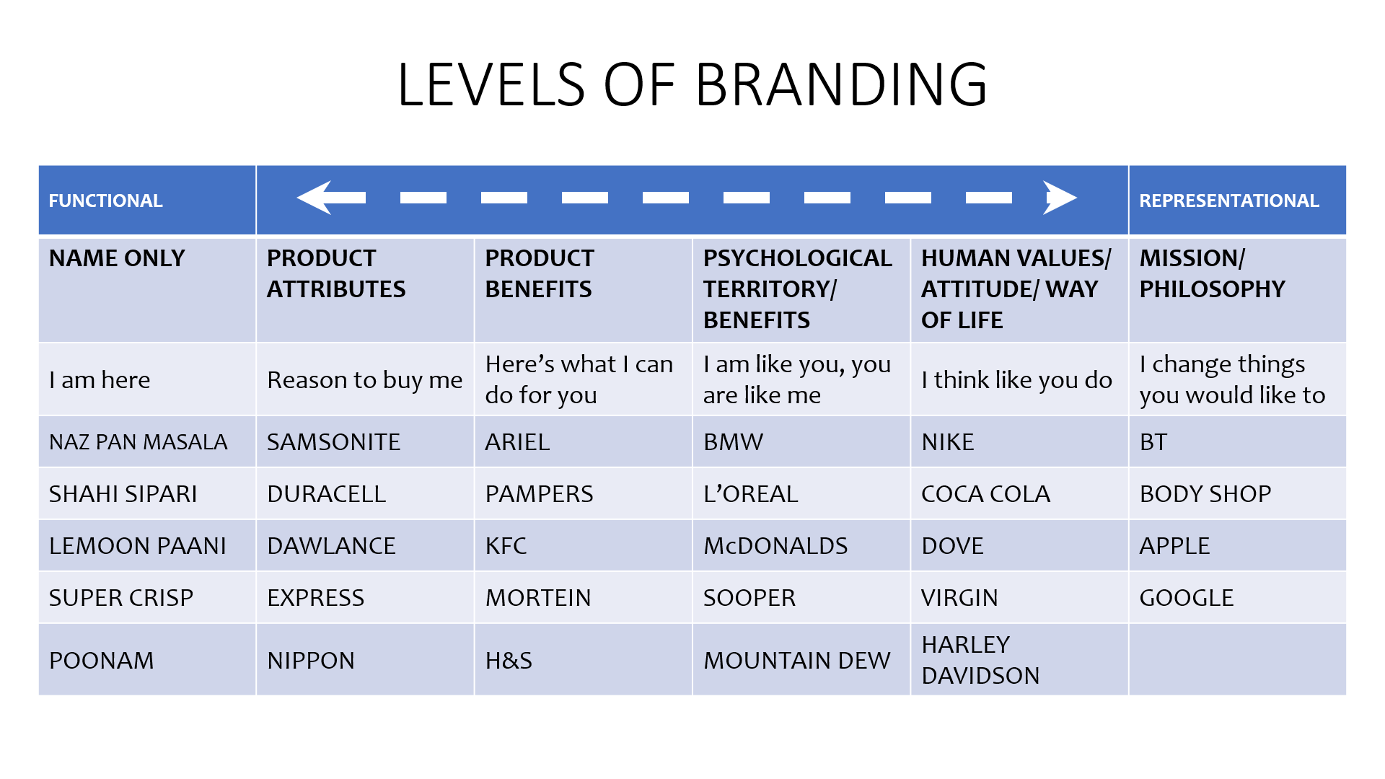
Each level represents a distinct stage of brand development:
- Name Only – "I am here"
At the most basic level, brands exist simply as names without significant associations or consumer expectations. This scenario often occurs in low-involvement categories, where customers do not think much about the product during purchase since the risks are low. Purchase decisions are usually driven by impulse, with the first brand that comes to mind (Top of Mind) being chosen. Examples include Naz Pan Masala, Shahi Sipari, Lemoon Paani, Super Crisp, and Poonam.

- Product Attributes – "Reason to buy me"
Moving up the branding hierarchy, brands emphasize product attributes to differentiate themselves. This level focuses on tangible qualities, such as durability, strength, and efficiency. Examples include Samsonite, Duracell, Dawlance, Express, and Nippon, highlighting physical features like reliability, durability, and strength.

- Product Benefits – "Here’s what I can do for you."
At this stage, brands focus on the benefits that they offer, which is crucial in consumer decision-making. Customers are persuaded by the advantages of using the product, such as Ariel (superior cleaning), Pampers (comfort for babies), KFC (delicious fast food), Mortein (pest control), and Head & Shoulders (anti-dandruff protection).

- Psychological Territory/Benefits – "I am like you; you are like me."
Brands at this level connect with consumers at a personal level by aligning with their aspirations and self-image. These brands become an extension of the consumer’s identity. Strong examples include BMW (status and recognition), L’Oreal (self-indulgence and pampering), McDonald’s (simplicity and happiness), Sooper (authenticity and happiness), and Mountain Dew (adventure and risk-taking).

- Human Values/Attitude/Way of Life – "I think like you do."
Beyond psychological associations, brands at this level reflect and shape consumer lifestyles and values. This is where branding transcends product utility to become part of consumers’ belief systems. Examples include Nike (winning spirit), Coca-Cola (happiness and togetherness), Dove (real beauty), Virgin (anti-establishment), and Harley Davidson (rebellion).

- Mission/Philosophy – "I change things you would like to."
At the highest level, brands go beyond commerce to embody a philosophy that influences society. These brands inspire change and often stand for social causes, innovation, or significant cultural movements. Iconic examples include BT (It’s good to talk), The Body Shop (ethical beauty and sustainability), Apple (Whatever we do, we believe in doing it differently), and Google (Organizing the world’s information and making it readily accessible).

3. The Strategic Importance of Branding Evolution
Understanding the various levels of branding is crucial for businesses aiming to build strong, resilient brands. Transitioning from functional branding to representational branding offers several advantages:
- Stronger Customer Loyalty: Consumers are likelier to remain loyal to brands that resonate with their values and aspirations rather than only product benefits.
- Higher Perceived Value: Brands with a psychological or philosophical positioning can command premium pricing and higher brand equity.
- Emotional Connection: Representational brands forge deep emotional connections, fostering long-term customer relationships and advocacy.
- Market Differentiation: Brands that stand for something beyond their products create differentiation in competitive markets.

4. When to Move to the Next Level
Determining the right time for a brand to evolve to the next level is intriguing. The answer lies in analyzing category communications in the market. Assess where most brands are positioned; for instance, many detergent brands in Pakistan focus on product benefits. When a new brand enters the market, it may differentiate itself at the psychological territory/benefits level.

Advertising literacy levels vary across markets and categories. In Pakistan's detergent category, advertisers have primarily educated consumers about functional benefits, such as stain removal, economy of use, fragrance, and the novelty of clothes.

5. Case Studies in Elevating Brand
Many brands have successfully moved to the next level when they determined it was the right time for such a transition. Some notable examples include:
- Apple: Originally known for computers, Apple has progressed into a leader in innovation, representing creativity, self-expression, and technological empowerment.
- Nike: Once merely a manufacturer of sports shoes, Nike now embodies motivation, determination, and the "Just Do It" attitude.
- Coca-Cola: Initially marketed as a refreshing beverage, Coca-Cola now symbolizes happiness, celebration, and global solidarity.

5. Conclusion
Branding is a journey that transforms a mere name into a philosophy. Companies that focus solely on product attributes risk becoming forgettable, while those that establish deep connections with consumers can achieve iconic status. The evolution from a functional brand to a representational one requires strategic planning, consistent messaging, and a keen understanding of human psychology. In today’s competitive landscape, the brands that succeed are not just selling products—they are selling identities, values, and dreams.

